HOSPITAL PATIENT ANALYTICS

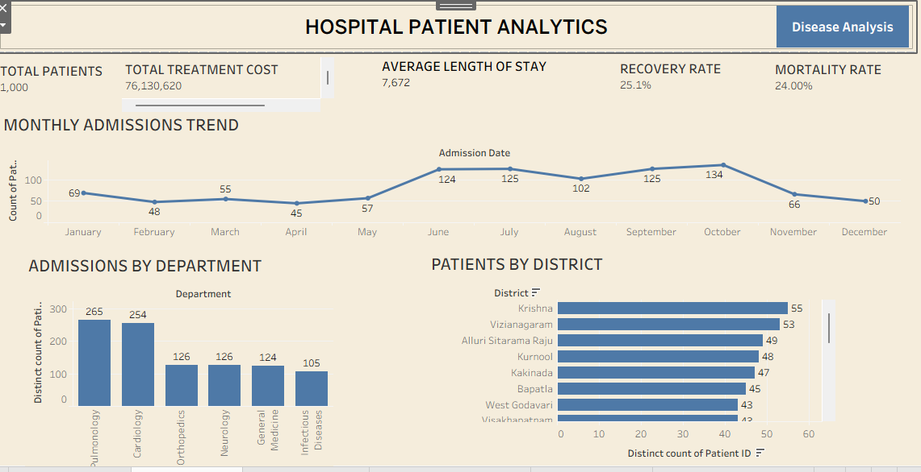
Key Insights
- Andhra Pradesh records the highest number of hospital admissions.
- Krishna district has the largest patient volume among all districts.
- Monthly admissions and discharges follow a similar trend, showing consistent hospital activity.
- The hospital treats a large number of patients while maintaining an overall recovery rate of 25.1%.
Business Recommendations
- Increase bed capacity and staff allocation in highadmission districts such as Krishna.
- Use monthly admission trends to improve workforce and resource planning.
- Focus preventive healthcare programs in districts with consistently high patient inflow.

Disease Analysis Dashboard

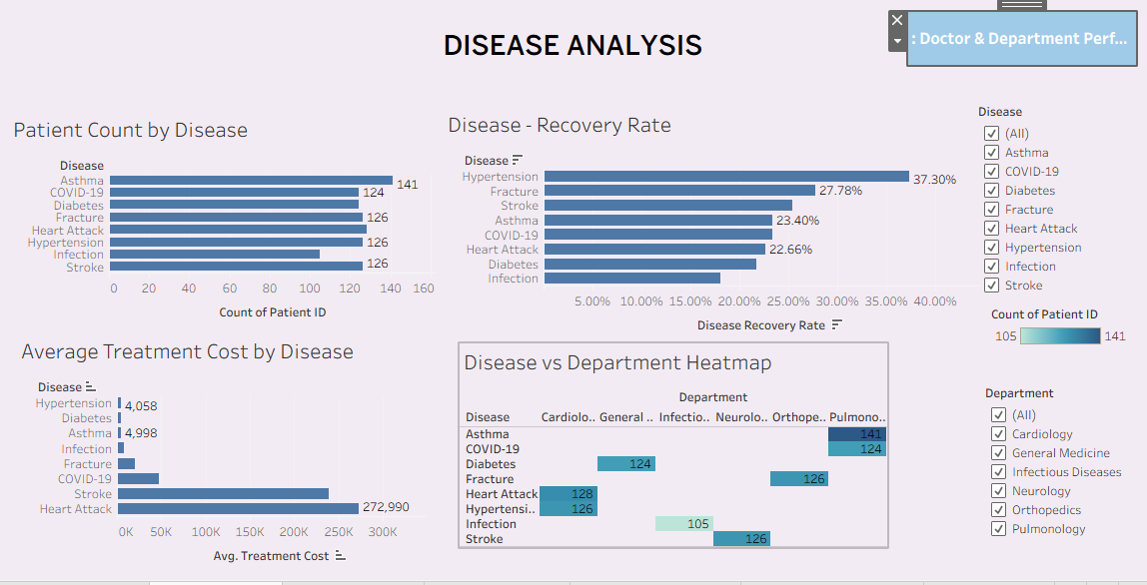

Key Insights
- Asthma has the highest patient count.
- Hypertension shows the highest recovery rate (37.3%).
- Infection has the lowest recovery rate, indicating poorer treatment outcomes.
- Critical diseases generate significantly higher treatment costs than moderate diseases.
Business Recommendations
- Expand respiratory care facilities to manage the growing number of asthma patients.
- Investigate treatment protocols for Infection to improve recovery outcomes.
- Develop early diagnosis programs to reduce the progression of diseases into critical stages.
Doctor & Department Performance Dashboard

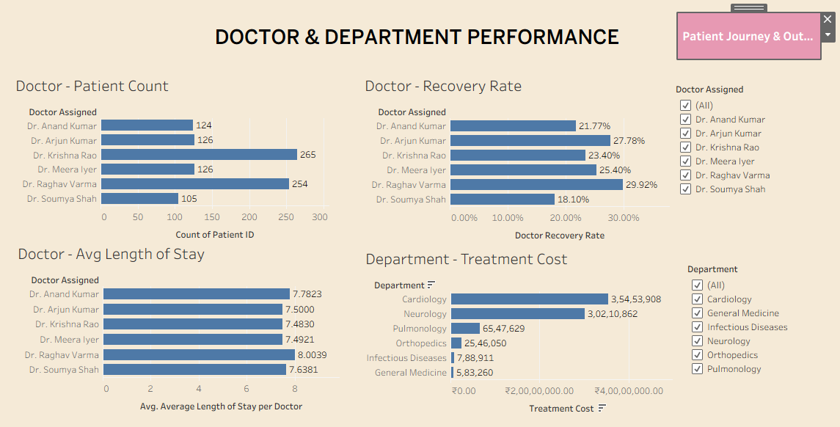
Key Insights
- Neurology is the most expensive department in the hospital.
- Dr. Raghav Varma has the highest recovery performance.
- Dr. Soumya Shah has the lowest recovery performance.
- Treatment cost varies considerably across departments, with Neurology contributing the largest share.
Business Recommendations
- Review Neurology expenses to identify opportunities for cost optimization without reducing quality.
- Recognize high-performing doctors and share their best practices across departments.
- Provide additional training and performance monitoring for lower-performing doctors.

Patient Journey & Outcomes Dashboard

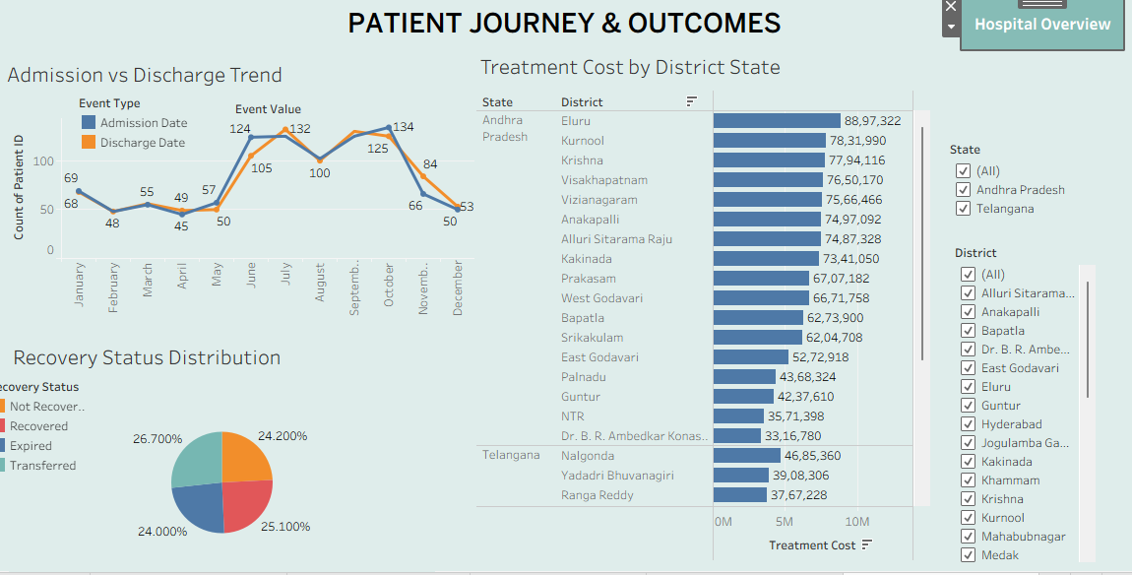

Key Insights
- The overall recovery rate is 25.1%. Recovery and discharge patterns vary by disease severity.
- Patients with critical diseases have longer hospital stays and higher treatment costs.
- Length of stay differs between doctors, indicating variation in patient management.

Business Recommendations
- Introduce standardized clinical pathways to reduce unnecessary hospital stay.
- Prioritize early intervention for critical patients to improve recovery rates.
- Monitor doctor-wise length of stay and optimize discharge planning to increase bed availability.

Conclusion
- The Tableau analysis shows that Asthma is the most common disease, Neurology is the highest-cost department, and Andhra Pradesh—especially Krishna district—has the greatest patient admissions. By improving infection treatment outcomes, optimizing Neurology costs, and allocating resources based on admission trends, the hospital can enhance both operational efficiency and patient care.

Public link
https://public.tableau.com/views/Tableauassignment_17889598713100/HospitalOverview?:language=en-US&:sid=&:redirect=auth&:display_count=n&:origin=viz_share_link

